**Phase 5**

**Lesson 5**

**Deploy your Application**

This section will guide you to:

* Configure Kubernetes cluster to push a random application to AWS EKS

**Step 1:**

* First create the docker image and upload to the docker hub.
* In command prompt give

**Kubectl run myangpod --image=13nishchith/myapplication**



**Kubectl get pods -o wide**



**Step 2:**

Create a uiservice.yml file

Add this content to that file.

apiVersion: v1

kind: Service

metadata:

name: ui-angularapp

spec:

selector:

app: angularapp

ports:

* Protocol: TCP

Port: 80

Targetport: 80

type: NodePort

**step 3:**

* run that .yml file

**kubectl create –f uiservice.yml**



* then label the pods

**kubectl label pod myangpod app=angularapp**



* to see services

**kubectl get svc**

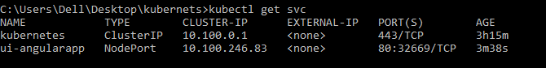

Add the ip(32669) to your security bounds of ur instance

* get the endpoints

**kuectl get endpoints ui-angularapp**



**step 4:**

copy the host url and service url and check in the browser

